**Generate Normals**

These are demonstrations when the vertex normal are not included with the x3d file and are thus generated by X3D parser inside GearVRf.

**noNormals_ptLight.x3d**

Two objects use the same vertices and texture coordinates. Red point light is on the right and a blue point light is on the left, with a white point light in the center.

The left image has vertex normals generated by the code while the right image has made up vertex normals to distinguish the two images as the only difference (along with color light placement).

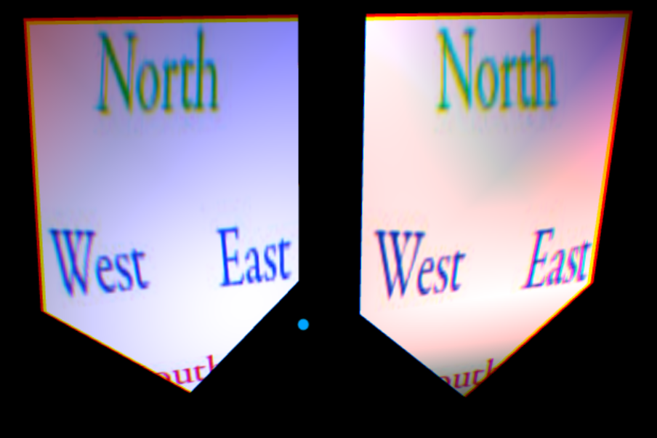

**teapotandtorusnonormals.x3d**

The normals and normalIndex were removed from both the torus and the teapot. The vertex normals are generated by the x3d parser in GearVR. A comparison model where the teapot and torus include the vertex normals in **teapotandtoruspointlights.x3d** is available inside the “Exported_by_3d_modeling_tools” folder.

